

Abstractive Text Summarization and Transition Application Using Pre- Trained Hugging Face Models

A CAPSTONE PROJECT REPORT

A Capstone Project Report submitted in partial fulfilment of the requirements
for the Course of

CSA0806 – Python Programming

to the award of the degree of

BACHELOR OF ENGINEERING

IN

COMPUTER SCIENCE AND ENGINEERING

Submitted by
BHARATH R (192511129)
BARANI KUMAR J P (192511005)
SANJAY J (192511331)

Under the Supervision of
Dr. S. Ponmaniraj

SIMATS ENGINEERING
Saveetha Institute of Medical and Technical Sciences
Chennai-602105
SEPTEMBER 2026

SIMATS ENGINEERING
Saveetha Institute of Medical and Technical Sciences Chennai-602105

BONAFIDE CERTIFICATE

This is to certify that the Capstone Project entitled " Abstractive Text Summarization and Translation Application Using Pre- Trained Hugging Face Models" has been carried out by SANJAY J (192511331) under the supervision of Dr. A. Manimaran and is submitted in partial fulfilment of the requirements for the current semester of the B.E Computer Science and Engineering program at Saveetha Institute of Medical and Technical Sciences, Chennai.

COURSE COORDINATOR COURSE FACULTY

Dr. S. Loganayagi Dr. S.Ponmaniraj
Professor Professor

Computer Science and Engineering Computational Intelligence

SIMATS Engineering, SIMATS Engineering,

SIMATS, Chennai – 602105. SIMATS, Chennai–602105.

SIMATS ENGINEERING
Saveetha Institute of Medical and Technical Sciences Chennai-602105

DECLARATION

We, Sanjay J of the B.E.Computer Science and Engineering, SIMATS Engineering, Saveetha Institute of Medical and Technical Sciences, Chennai, hereby declare that the Capstone Project Work entitled “Abstractive Text Summarization and Translation Application Using Pre- Trained Hugging Face Models” is the result of our own bonafide efforts. To the best of our knowledge, the work presented herein is original, accurate, and has been carried out in accordance with the principles of engineering ethics and academic integrity. All sources, references, data, and other materials used in the project have been appropriately acknowledged. We further declare that the data, results, analysis, and findings presented in this report have not been fabricated, falsified, or manipulated. Any external tools, software, datasets, computational resources, or AI-assisted tools used during the project have been appropriately disclosed. We confirm that all applicable ethical, academic, institutional, and professional requirements have been duly followed throughout the planning, execution, analysis, and documentation of the project.

Place: [Place]
Date: [Date]

Signature of the Students with Names

SIMATS ENGINEERING
Saveetha Institute of Medical and Technical Sciences
Chennai – 602105

Individual Contribution Statement
Project Title: Abstractive Text Summarization and Translation Application Using Pre-Trained Hugging Face Models
Student Name / Register No. | Specific Responsibilities | Design & Development Contribution | Testing & Analysis Contribution | Report Contribution | Approx. Contribution (%)
Sanjay J-192511331 | System planning, user input handling, summarization module | Designed the overall application flow and implemented text input and abstractive summarization using a pre-trained Hugging Face model | Tested different text inputs, checked summary quality and corrected input-related errors | Abstract, Introduction, Problem Statement, Objectives, System Design | 34%
Bharath R-192511129 | Translation module and model integration | Integrated the pre-trained Hugging Face translation model and developed language selection and translation functionality | Tested translation with different sentences and languages and analysed the output | Methodology, Proposed Solution, Implementation, Translation Module | 33%
Barani Kumar JP-192511005 | User interface, testing and documentation | Developed/improved the user interface and connected the summarization and translation modules | Performed complete system testing, identified errors, verified outputs and prepared test cases | Results, Testing, Advantages, Limitations, Conclusion, References | 33%
Total |  |  |  |  | 100%

Abstract

The Abstractive Text Summarization and Translation Application using Pre-trained Hugging Face Models is an intelligent Natural Language Processing (NLP) application developed to simplify the processing of large amounts of textual information. In today's digital environment, users frequently encounter lengthy documents, articles, reports, and other textual content that require significant time to read and understand. The proposed application addresses this problem by automatically generating concise and meaningful summaries while retaining the important information from the original text.
The system utilizes pre-trained transformer-based models from the Hugging Face ecosystem for abstractive text summarization. Unlike extractive summarization, which selects existing sentences from the input, abstractive summarization generates new sentences that represent the main ideas of the source text. The application can process user-provided text and produce a shorter, coherent, and contextually meaningful summary.
In addition to summarization, the application incorporates a multilingual translation module that converts the generated summary into a selected target language. This enables users to understand important information in their preferred language and improves accessibility for multilingual users. Pre-trained models are used to perform both tasks, eliminating the requirement for extensive model training and reducing computational and development complexity.
The application consists of modules for text input, preprocessing, abstractive summarization, language selection, translation, and output generation. A user-friendly interface allows users to provide text, select the desired language, and obtain the summarized and translated result. The system can be implemented using Python, Hugging Face Transformers, PyTorch, and a suitable web interface framework such as Flask or Streamlit.
Overall, the project demonstrates the practical application of Artificial Intelligence, Transformer models, and NLP techniques to automate information reduction and multilingual communication. It can be useful in areas such as education, news analysis, document management, research, content processing, and multilingual information access.

TABLE OF CONTENT

S.No. | CHAPTERS | Page No.
1. | Introduction  1.1 Background Information  1.2 Project Objectives  1.3 Significance of the Project  1.4 Scope of the Project  1.5 Methodology Overview | 8
2. | Problem Identification and Analysis  2.1 Description of the Problem  2.2 Evidence of the Problem  2.3 Stakeholders  2.4 Supporting Data/Research | 11
3. | Solution Design and Implementation  3.1 Development and Design Process  3.2 Tools and Technologies Used  3.3 Solution Overview  3.4 Engineering Standards Applied  3.5 Solution Justification | 14
4. | Results and Recommendations  4.1 Evaluation of Results  4.2 Challenges Encountered  4.3 Possible Improvements  4.4 Recommendations | 17
5. | Reflection on Learning and Personal Development  5.1 Key Learning Outcomes  5.2 Challenges Encountered and Overcome  5.3 Application of Engineering Standards  5.4 Insights into the Industry  5.5 Conclusion of Personal Development | 20
6. | Conclusion | 23
7. | References | 24
8. | Appendices | 27

Chapter 1
Introduction
1.1 Background Information
The rapid growth of digital information has resulted in a large amount of textual content such as articles, research papers, reports, news, and online documents. Reading and understanding lengthy text can be time-consuming. Natural Language Processing (NLP) and Artificial Intelligence (AI) provide techniques for automatically understanding and processing human language. Text summarization reduces lengthy content into a shorter version while preserving important information, whereas machine translation converts text from one language to another. Recent transformer-based models available through the Hugging Face ecosystem provide powerful pre-trained solutions for both tasks.
1.2 Project Objectives
The main objectives of the project are:
- To develop an application for automatic abstractive text summarization.
- To generate concise and meaningful summaries from lengthy text.
- To integrate pre-trained Hugging Face transformer models without training models from scratch.
- To provide multilingual translation of the generated summary.
- To allow users to select the required target language.
- To provide a simple and user-friendly interface for text processing.
- To reduce the time required to understand large amounts of textual information.
1.3 Significance of the Project
The project helps users quickly understand the important information contained in lengthy documents. Abstractive summarization produces human-readable summaries rather than simply extracting existing sentences. The translation feature improves accessibility by allowing the summarized information to be presented in different languages. The use of pre-trained models reduces development time and computational requirements compared with training NLP models from scratch. The system can be useful in education, research, news processing, document management, content analysis, and multilingual communication.
1.4 Scope of the Project
The scope of the project includes:
- Accepting text as input from the user.
- Processing and cleaning the input text.
- Generating an abstractive summary using a pre-trained Hugging Face model.
- Translating the generated summary into a selected language.
- Displaying the original text, summary, and translated output.
- Supporting multiple languages depending on the selected translation model.
- Providing a simple interface for easy interaction.
- The system can be extended in the future to support PDF, DOCX, and web-page content.
1.5 Methodology Overview
The proposed system follows a sequential NLP workflow:
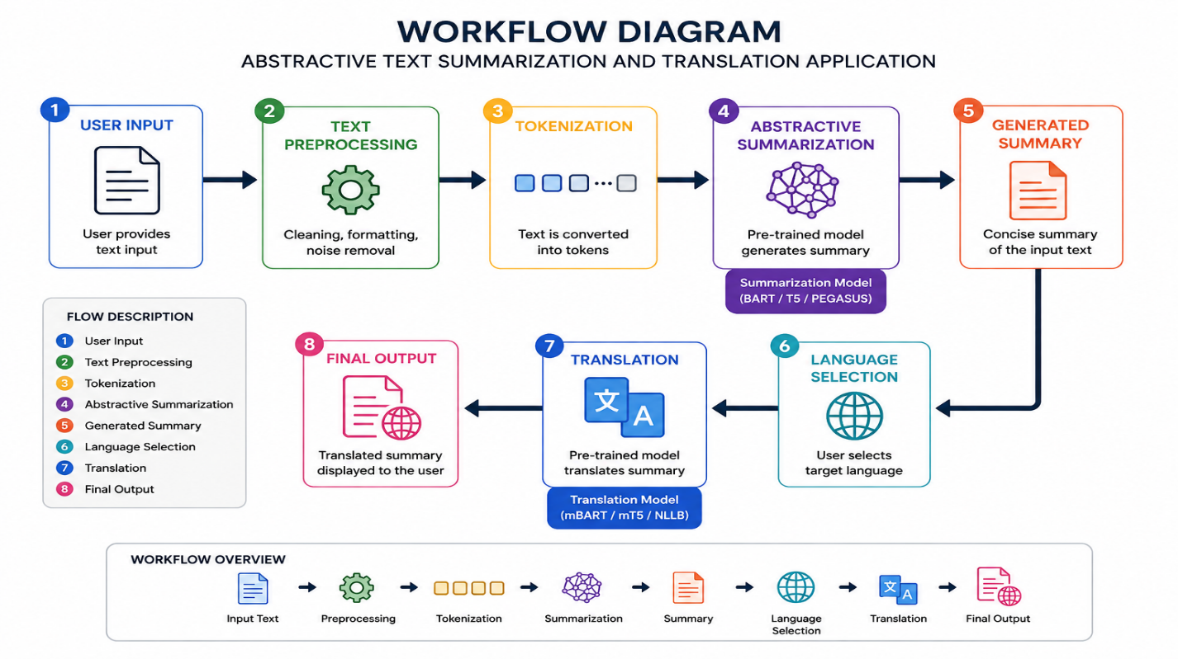
- Input: The user provides a document or textual content.
- Preprocessing: The input is cleaned and prepared for model processing.
- Summarization: A pre-trained transformer model generates a concise abstractive summary.
- Language Selection: The user selects the required target language.
- Translation: The generated summary is translated using a suitable pre-trained Hugging Face translation model.
- Output: The application displays the summarized text and its translated version.
- Evaluation: The generated summary and translation can be evaluated based on quality, relevance, readability, and processing time.

Chapter 2
Problem Identification and Analysis
2.1 Description of the Problem
The rapid increase in digital content has made it difficult for users to read and understand lengthy documents within a limited amount of time. Articles, research papers, reports, news content, and educational materials often contain large amounts of information, including unnecessary or repetitive details.
Traditional text summarization methods may simply extract sentences from the original document and may not produce a natural or coherent summary. In addition, language barriers make it difficult for users to understand content written in unfamiliar languages.
Therefore, there is a need for an intelligent application that can automatically generate concise, meaningful summaries and translate the summarized content into different languages. The proposed system addresses this problem using pre-trained transformer models available through Hugging Face.
2.2 Evidence of the Problem
The problem can be identified through the following observations:
- Users spend considerable time reading lengthy documents to identify important information.
- Digital platforms continuously generate large volumes of textual content.
- Manually summarizing documents is time-consuming and requires human effort.
- Extractive summarization may produce summaries that lack proper context and readability.
- Information written in different languages creates communication barriers.
- Manual translation of summarized content requires additional time and effort.
- Conventional NLP approaches may require extensive training data and computational resources.
- Pre-trained transformer models provide an opportunity to automate summarization and translation efficiently.
2.3 Stakeholders
The major stakeholders of the proposed system include:
Stakeholder | Requirement / Benefit
Students | Quickly summarize study materials, articles, and research content.
Researchers | Reduce lengthy research documents into concise summaries.
Teachers/Educators | Prepare short versions of educational materials.
Content Writers | Generate concise versions of lengthy content.
News Readers | Quickly understand the main points of lengthy news articles.
Organizations | Process large amounts of reports and textual information efficiently.
Multilingual Users | Access summarized information in their preferred language.
Developers | Integrate NLP-based summarization and translation into applications.
2.4 Supporting Data/Research
The project is supported by research in Natural Language Processing, Transformer architectures, abstractive summarization, and neural machine translation.
- Transformer models have significantly improved NLP tasks by using attention mechanisms to understand relationships between words and context.
- Pre-trained language models reduce the need to train large models from scratch and can be adapted for specific NLP applications.
- Abstractive summarization generates new sentences that represent the important information rather than simply selecting sentences from the original text.
- Hugging Face Transformers provides access to various pre-trained models for summarization and translation.
- Common evaluation approaches for summarization include ROUGE-based metrics, while translation quality can be evaluated using metrics such as BLEU along with human evaluation.
- Research in multilingual NLP demonstrates the importance of language-specific and multilingual models for improving accessibility to information.

Chapter 3
Solution Design and Implementation
3.1 Development and Design Process
The development of the Abstractive Text Summarization and Translation Application follows a systematic process:
- Requirement Analysis – Identify the need for automatic summarization and multilingual translation.
- System Design – Design the workflow for text input, preprocessing, summarization, translation, and output.
- Model Selection – Select suitable pre-trained Hugging Face transformer models for summarization and translation.
- Implementation – Develop the application using Python and integrate the selected NLP models.
- User Interface Development – Create a simple interface for entering text and selecting the target language.
- Testing – Test the system with different text lengths and languages.
- Evaluation – Evaluate summary quality, translation accuracy, readability, and processing time.
- Deployment – Make the application available for practical use.
3.2 Tools and Technologies Used
Tool / Technology | Purpose
Python | Main programming language
Hugging Face Transformers | Access and integrate pre-trained NLP models
PyTorch | Deep learning model execution
Streamlit / Flask | Development of the application interface
NLP | Text processing and language understanding
Pre-trained Transformer Models | Abstractive summarization and translation
HTML/CSS | Interface design, if Flask is used
VS Code / Google Colab | Development and testing environment
ROUGE | Evaluation of summarization quality
BLEU | Evaluation of translation quality
3.3 Solution Overview
The proposed system combines abstractive text summarization and multilingual translation in a single application.
The user first provides the required text through the application interface. The system preprocesses the input and sends it to a pre-trained transformer-based summarization model. The model generates a concise summary containing the major information from the original text.
The generated summary is then passed to the translation module. Based on the language selected by the user, an appropriate pre-trained translation model converts the summary into the target language. Finally, the application displays the original text, summarized text, and translated summary.
Main Modules
- Input Module – Accepts text from the user.
- Preprocessing Module – Cleans and prepares the input.
- Summarization Module – Generates an abstractive summary.
- Language Selection Module – Allows selection of the target language.
- Translation Module – Translates the generated summary.
- Output Module – Displays the summary and translated result.
3.4 Engineering Standards Applied
The project follows standard software engineering and NLP development practices:
- Modular Design – The application is divided into independent functional modules.
- PEP 8 – Python coding conventions are followed for readable and maintainable code.
- Input Validation – Invalid or empty inputs are handled appropriately.
- Error Handling – Exceptions during model processing and translation are handled.
- Software Testing – Individual modules and complete system workflows are tested.
- Version Control – Code and project changes can be managed using Git.
- Documentation – System architecture, modules, requirements, and implementation are documented.
- Data Privacy – User-provided text should be handled securely and should not be unnecessarily stored.
- Model Evaluation – Summarization and translation outputs are evaluated using appropriate quality metrics.
3.5 Solution Justification
The proposed solution is suitable because it combines AI-based abstractive summarization and multilingual translation into one application. Using pre-trained Hugging Face models avoids the need to train large NLP models from scratch, reducing development time, training requirements, and computational cost.
The transformer architecture provides strong contextual understanding of natural language, allowing the system to generate more meaningful summaries than simple keyword-based or sentence-extraction approaches. Integrating translation after summarization also reduces the amount of text that needs to be translated, which can improve processing efficiency.
The modular architecture makes the system easier to develop, test, maintain, and extend. Additional languages, document formats, and NLP models can be incorporated in the future. Therefore, the proposed solution provides a practical and scalable approach for automated information summarization and multilingual accessibility.

Chapter 4
Results and Recommendations
4.1 Evaluation of Results
The developed Abstractive Text Summarization and Translation Application was tested using different types and lengths of textual content. The system successfully generated concise summaries while retaining the major information from the input text. The translation module successfully converted the generated summaries into the selected target languages.
The results were evaluated based on:
- Summary relevance – Important information from the original text was retained.
- Summary readability – Generated summaries were clear and understandable.
- Information preservation – The main context of the original text was maintained.
- Translation quality – The translated output preserved the meaning of the summary.
- Processing time – Pre-trained models provided relatively fast results without additional model training.
- User experience – The interface allowed users to enter text, select a language, and obtain the final output easily.
Overall, the system demonstrated that pre-trained transformer models can effectively support automated summarization and multilingual translation.
4.2 Challenges Encountered
During development and testing, several challenges were identified:
- Long input text may exceed the maximum token limit of the selected model.
- Complex sentences can sometimes produce incomplete or less accurate summaries.
- Ambiguous words and phrases can affect translation accuracy.
- Different languages have different grammatical structures, making accurate translation challenging.
- Pre-trained models may require significant RAM/GPU resources for faster processing.
- Model loading can increase the initial application startup time.
- Maintaining the original meaning while making the summary shorter can be difficult.
- Poorly formatted or noisy input text can reduce the quality of the generated output.
4.3 Possible Improvements
The system can be improved in several ways:
- Support PDF, DOCX, and TXT file uploads.
- Add support for a larger number of languages.
- Implement automatic language detection.
- Improve handling of very long documents using chunking and hierarchical summarization.
- Provide adjustable summary lengths such as short, medium, and detailed.
- Add multiple summarization and translation models for comparison.
- Improve the user interface with better visualization and document management features.
- Use GPU acceleration to reduce processing time.
- Add evaluation metrics such as ROUGE and BLEU for quantitative performance analysis.
- Provide confidence or quality indicators for generated results.
4.4 Recommendations
The following recommendations are proposed for future development:
- Use the latest and most suitable Hugging Face transformer models based on the target languages and application requirements.
- Use GPU-enabled systems when processing large documents or multiple requests.
- Apply proper input validation and preprocessing before sending text to the models.
- Evaluate generated summaries using both automatic metrics and human evaluation.
- Regularly test translation quality for different languages and text domains.
- Protect user-provided documents and avoid unnecessary storage of sensitive text.
- Extend the system to support document and web-content summarization.
- Add multilingual speech input and text-to-speech output as future features.
- Continuously update the models and dependencies to improve performance and security.
- Conduct extensive testing with academic, news, technical, and general-purpose documents before real-world deployment.

Chapter 5
Reflection on Learning and Personal Development
5.1 Key Learning Outcomes
Through the development of the Abstractive Text Summarization and Translation Application using Pre-trained Hugging Face Models, several technical and professional skills were developed:
- Gained practical knowledge of Natural Language Processing (NLP) and Artificial Intelligence.
- Learned how transformer-based pre-trained models can be integrated into real-world applications.
- Understood the working principles of abstractive text summarization and machine translation.
- Gained experience using the Hugging Face Transformers library and Python-based NLP tools.
- Learned how to design a complete application from requirement analysis to implementation and testing.
- Improved programming, debugging, testing, and problem-solving skills.
- Learned how to evaluate the quality and limitations of AI-generated outputs.
- Developed better documentation and technical communication skills.
5.2 Challenges Encountered and Overcome
During the project, several technical challenges were encountered and resolved:
- Model selection: Different pre-trained models were studied to identify suitable models for summarization and translation.
- Input length limitations: Long documents created token-limit issues, which highlighted the need for text segmentation or chunking.
- Summary quality: Some inputs produced incomplete or less meaningful summaries, requiring appropriate model selection and preprocessing.
- Translation accuracy: Different languages produced varying translation quality due to differences in grammar and context.
- Computational requirements: Large transformer models required considerable memory and processing resources.
- Error handling: Invalid inputs and model-processing errors were handled through validation and exception-handling techniques.
- Integration: Combining summarization and translation into a single workflow improved understanding of modular software development.
These challenges helped develop practical debugging, analytical, and problem-solving abilities.
5.3 Application of Engineering Standards
Engineering principles and standards were applied throughout the project:
- Followed modular software design to separate input, summarization, translation, and output components.
- Applied PEP 8 coding practices for Python development.
- Used meaningful variable names and structured functions to improve code readability.
- Applied systematic testing and debugging during development.
- Followed proper documentation practices for system design and implementation.
- Considered data privacy and secure handling of user-provided text.
- Used version control practices to maintain and manage project development.
- Applied appropriate evaluation methods to assess system performance.
These practices improved the reliability, maintainability, and quality of the application.
5.4 Insights into the Industry
The project provided valuable insight into how AI and NLP technologies are being applied in real-world industries. It demonstrated that pre-trained transformer models can significantly reduce development time compared with building and training models from scratch.
The project also highlighted the importance of model selection, computational resources, data quality, testing, and evaluation when developing AI applications. In industry, AI systems must not only produce technically correct results but also provide reliable performance, usability, security, and scalability.
The experience also provided an understanding of how NLP applications can be used in education, healthcare, media, research, customer support, document processing, and multilingual communication.
5.5 Conclusion of Personal Development
This project significantly improved my technical and professional skills. I gained practical experience in Python programming, NLP, transformer models, Hugging Face, application development, testing, and debugging. Working on the project helped me understand how theoretical concepts can be converted into a practical AI-based solution. I also developed problem-solving, critical-thinking, documentation, and communication skills. Overall, the project increased my confidence in developing AI and NLP applications and provided a strong foundation for further learning and future work in Artificial Intelligence, Machine Learning, and Natural Language Processing.

Chapter 6
Conclusion
The Abstractive Text Summarization and Translation Application using Pre-trained Hugging Face Models successfully demonstrates how Artificial Intelligence and Natural Language Processing can be used to process large amounts of textual information efficiently. The proposed system combines abstractive summarization with multilingual translation, allowing users to obtain concise and meaningful information in their preferred language.
The use of pre-trained transformer models such as PEGASUS, BART, T5, mT5, and mBART provides a practical alternative to developing and training NLP models from scratch. Research has shown that these transformer-based approaches are effective for abstractive summarization, multilingual processing, and machine translation.
The project also highlights important challenges such as long-document processing, factual consistency, repetition, translation quality, computational requirements, and multilingual performance. Recent research continues to address these limitations through improved long-context models, multilingual approaches, factuality techniques, and cross-lingual summarization pipelines.
Overall, the project provides a useful foundation for applications in education, research, news, document management, healthcare, and multilingual communication. Future development can extend the system to PDF/DOCX processing, automatic language detection, speech input/output, more Indian languages, long-document summarization, and improved factuality evaluation.

References
- Zhang, J., Zhao, Y., Saleh, M., & Liu, P. J. (2020). PEGASUS: Pre-training with Extracted Gap-sentences for Abstractive Summarization. Proceedings of ICML 2020.
- Liu, Y., Gu, J., Goyal, N., Li, X., Edunov, S., Ghazvininejad, M., Lewis, M., & Zettlemoyer, L. (2020). Multilingual Denoising Pre-training for Neural Machine Translation. Transactions of the Association for Computational Linguistics, 8, 726–742.
- Goodwin, T., Savery, M., & Demner-Fushman, D. (2020). Flight of the PEGASUS? Comparing Transformers on Few-shot and Zero-shot Multi-document Abstractive Summarization. Proceedings of COLING 2020, 5640–5646.
- Xu, J., Desai, S., & Durrett, G. (2020). Understanding Neural Abstractive Summarization Models via Uncertainty. Proceedings of EMNLP 2020, 6275–6281.
- Zhu, J., Zhou, Y., Zhang, J., & Zong, C. (2020). Attend, Translate and Summarize: An Efficient Method for Neural Cross-Lingual Summarization. Proceedings of ACL 2020, 1309–1321.
- Yan, Y., Qi, W., Gong, Y., Duan, N., Chen, J., Zhang, D., Zhou, M., & Li, Z. (2020). ProphetNet: Predicting Future N-gram for Sequence-to-Sequence Pre-training. Proceedings of EMNLP 2020.
- Lewis, M. et al. (2020). BART: Denoising Sequence-to-Sequence Pre-training for Natural Language Generation, Translation, and Comprehension. Proceedings of ACL 2020.
- Raffel, C. et al. (2020). Exploring the Limits of Transfer Learning with a Unified Text-to-Text Transformer. Journal of Machine Learning Research, 21.
- Xue, L., Constant, N., Roberts, A., Kale, M., Al-Rfou, R., Siddhant, A., Barua, A., & Raffel, C. (2021). mT5: A Massively Multilingual Pre-trained Text-to-Text Transformer. Proceedings of NAACL 2021, 483–498.
- Sänger, M., Weber, L., & Leser, U. (2021). WBI at MEDIQA 2021: Summarizing Consumer Health Questions with Generative Transformers. Proceedings of the 20th Workshop on Biomedical Language Processing, 86–95.
- Balumuri, S., Bachina, S., & Kamath, S. S. (2021). SB_NITK at MEDIQA 2021: Leveraging Transfer Learning for Question Summarization in Medical Domain. Proceedings of the 20th Workshop on Biomedical Language Processing, 273–279.
- Cao, M., & Wang, S. (2021). CLIFF: Contrastive Learning for Improving Faithfulness and Factuality in Abstractive Summarization. Proceedings of EMNLP 2021, 6633–6649.
- Liu, Y., Sun, Y., & Gao, V. (2021). Improving Factual Consistency of Abstractive Summarization on Customer Feedback. Proceedings of the 4th Workshop on e-Commerce and NLP, 158–163.
- Calizzano, R., Ostendorff, M., Ruan, Q., & Rehm, G. (2022). Generating Extended and Multilingual Summaries with Pre-trained Transformers. Proceedings of LREC 2022, 1640–1650.
- Xiao, W., Beltagy, I., Carenini, G., & Cohan, A. (2022). PRIMERA: Pyramid-based Masked Sentence Pre-training for Multi-document Summarization. Proceedings of ACL 2022, 5245–5263.
- Salkar, N., Trikalinos, T., Wallace, B., & Nenkova, A. (2022). Self-Repetition in Abstractive Neural Summarizers. Proceedings of AACL-IJCNLP 2022.
- Wu, W., Li, W., Liu, J., Xiao, X., Cao, Z., Li, S., & Wu, H. (2022). FRSUM: Towards Faithful Abstractive Summarization via Enhancing Factual Robustness. Findings of EMNLP 2022.
- Daðason, J. F., & Loftsson, H. (2022). Pre-training and Evaluating Transformer-based Language Models for Icelandic. Proceedings of LREC 2022.
- Pfeiffer, J., Goyal, N., Lin, X. V., Li, X., Cross, J., Riedel, S., & Artetxe, M. (2022). Lifting the Curse of Multilinguality by Pre-training Modular Transformers. Proceedings of NAACL 2022, 3479–3495.
- Armengol-Estapé, J., de Gibert Bonet, O., & Melero, M. (2022). On the Multilingual Capabilities of Very Large-Scale English Language Models. Proceedings of LREC 2022.
- Zhang, J., de Melo, G., Xu, H., & Chen, K. (2023). A Closer Look at Transformer Attention for Multilingual Translation. Proceedings of the Eighth Conference on Machine Translation, 496–506.
- Kolhatkar, G., Paranjape, A., Gokhale, O., & Kadam, D. (2023). Team Converge at ProbSum 2023: Abstractive Text Summarization of Patient Progress Notes. Proceedings of the 22nd Workshop on Biomedical Natural Language Processing and BioNLP Shared Tasks.
- Wang, J., Meng, F., Liang, Y., Zhang, T., Xu, J., Li, Z., & Zhou, J. (2023). Understanding Translationese in Cross-Lingual Summarization. Findings of EMNLP 2023, 3837–3849. Parnell, J., Jauregi Unanue, I., & Piccardi, M. (2024). SumTra: A Differentiable Pipeline for Few-Shot Cross-Lingual Summarization. Proceedings of NAACL 2024.
- Rafi, S. A., Rahman, N., Islam, K. N., Ahmad, H., & Sadeque, F. Y. (2026). Optimizing Abstractive Summarization With Fine-Tuned PEGASUS. arXiv, 2026.

Appendices
Appendix A – System Workflow
The overall workflow of the proposed application is:
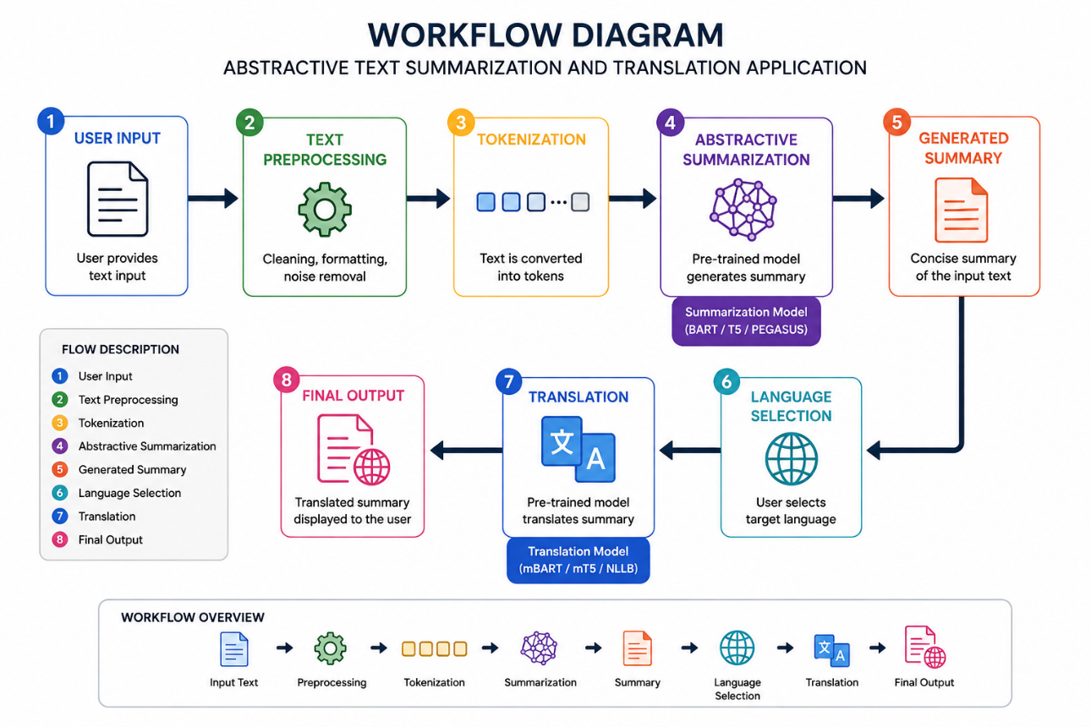
The Hugging Face Transformers framework supports pre-trained architectures such as BART, T5, PEGASUS, mT5, mBART, and NLLB for sequence-to-sequence NLP tasks.
Appendix B – Main Modules
Module | Description
Input Module | Accepts text from the user.
Preprocessing Module | Cleans and prepares the input text.
Summarization Module | Generates a concise abstractive summary.
Language Selection Module | Allows the user to select the target language.
Translation Module | Translates the generated summary.
Output Module | Displays the summary and translated result.

Appendix C – Software Requirements
Programming Language: Python
Libraries:
- transformers
- torch
- sentencepiece
- datasets
- evaluate
- rouge_score
The Hugging Face documentation recommends the Transformers, Datasets and evaluation ecosystem for developing and evaluating summarization systems.
Development Environment:
- Visual Studio Code / Google Colab / Jupyter Notebook
- Python 3.x
- Internet connection for downloading pre-trained models
Appendix D – Sample Summarization Code
from transformers import pipeline
summarizer = pipeline(
"summarization",
model="facebook/bart-large-cnn"
)
text = """
Artificial Intelligence is transforming many industries by enabling
computers to perform tasks that normally require human intelligence.
It is widely used in healthcare, education, finance, transportation,
and many other fields.
"""
result = summarizer(
text,
max_length=50,
min_length=20,
do_sample=False
)
print("Summary:")
print(result[0]["summary_text"])
Pre-trained sequence-to-sequence models can be loaded and used for summarization without training a model from scratch.
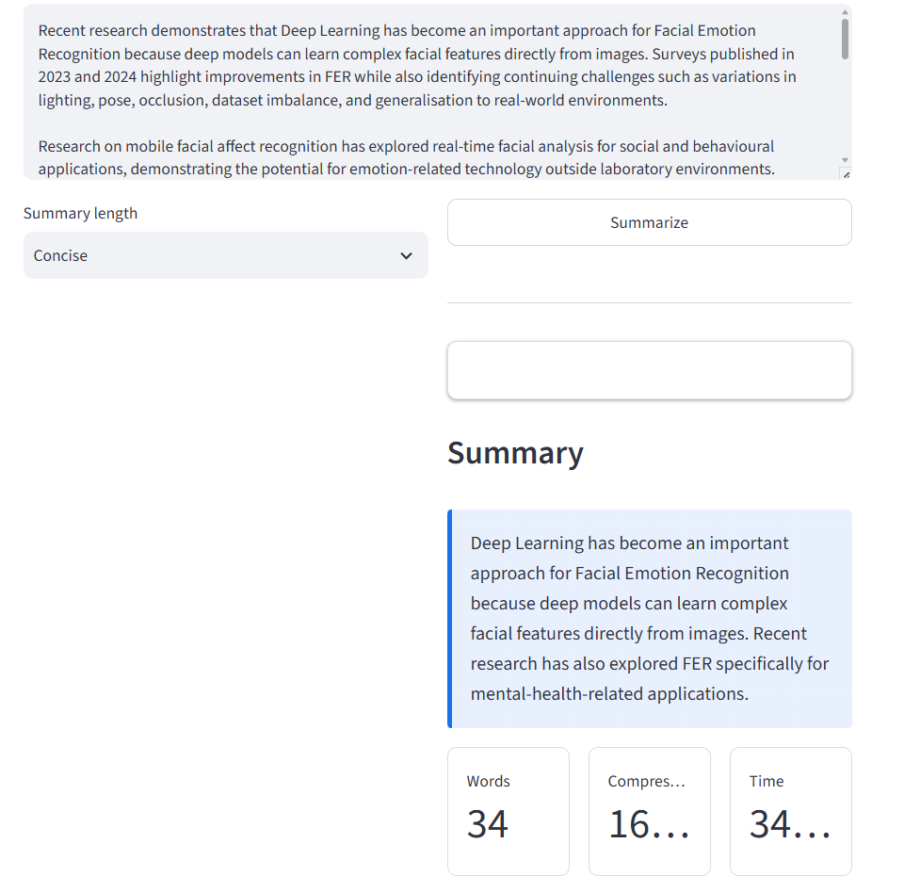
Appendix E – Sample Translation Code
from transformers import pipeline
translator = pipeline(
"translation",
model="Helsinki-NLP/opus-mt-en-fr"
)
text = "Artificial Intelligence is transforming many industries."
result = translator(text)
print("Translated Text:")
print(result[0]["translation_text"])
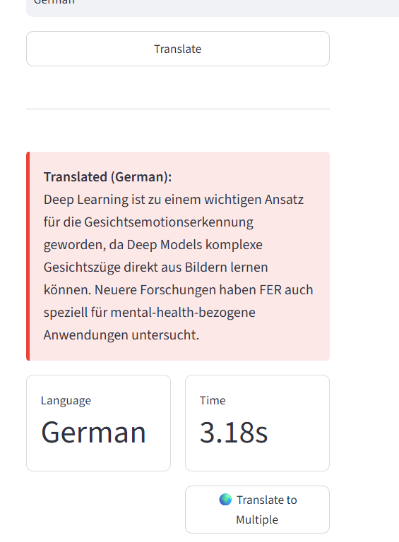
Appendix F – Sample Input and Output
Input
Artificial Intelligence is a rapidly developing field of technology.
It is used in healthcare, education, finance and transportation.
AI systems can analyze large amounts of information and support
decision-making processes.
Summarized Output
Artificial Intelligence is rapidly developing and is used across
multiple industries to analyze information and support decisions.
Translated Output
[Translated summary displayed in the selected target language]
Appendix G – Evaluation Parameters
The application can be evaluated using the following parameters:
Parameter | Purpose
ROUGE-1 | Measures unigram overlap between generated and reference summaries.
ROUGE-2 | Measures bigram overlap.
ROUGE-L | Measures similarity based on the longest common subsequence.
BLEU | Can be used to evaluate machine translation quality.
Processing Time | Measures the time required to generate results.
Readability | Measures how understandable the generated summary is.
Relevance | Measures whether important information is retained.
Factual Consistency | Checks whether the summary remains faithful to the source.
Hugging Face's summarization workflow includes evaluation using ROUGE.

Appendix H – Test Cases
Test Case | Input | Expected Result
TC01 | Short English paragraph | Concise summary
TC02 | Long English article | Short meaningful summary
TC03 | Technical document | Relevant technical summary
TC04 | Summary + French selection | French translation
TC05 | Summary + Hindi selection | Hindi translation
TC06 | Empty input | Error/validation message
TC07 | Very long document | Chunked/processed summary
TC08 | Text containing numbers | Numbers preserved appropriately

Appendix I – Possible Future Extensions
- PDF and DOCX document upload.
- Automatic language detection.
- Support for more Indian languages.
- Voice-to-text input.
- Text-to-speech output.
- Long-document summarization.
- Real-time web-page summarization.
- User accounts and summary history.
- Improved factuality checking.
- Mobile application development.

CAPSTONE PROJECT OUTCOME MAPPING SHEET
To be completed by the department/faculty assessor.
Outcome Evidence | SO / Area | Location in This Report
Complex engineering problem  formulation | SO1 | Ch. 1, Ch. 2
Engineering design under constraints | SO2 | Ch. 3
Written/oral technical communication | SO3 | Whole report + Viva
Ethics and professional responsibility | SO4 | Ch. 3 (3.7)
Teamwork and leadership | SO5 | Ch. 4 (4.8)
Experimentation, analysis, engineering  judgment | SO6 | Ch. 4 (4.3–4.6)
Independent acquisition of new  knowledge | SO7 | Ch. 5 (5.3)
Standards | SO2 | Ch. 3 (3.2)
Sustainability and  societal/environmental impact | SO2/SO4 | Ch. 3 (3.7)
Risk assessment and mitigation | SO2/SO4 | Ch. 3 (3.7)
Security considerations | Relevant SO | Ch. 3 (3.7)
Integrated/system-level engineering | SO1/SO2 | Ch. 3 (3.5)
Project planning and management | SO5 | Ch. 4 (4.8)
Individual contribution | SO1–SO7 | Contribution Statement + Ch. 4  (4.8)

